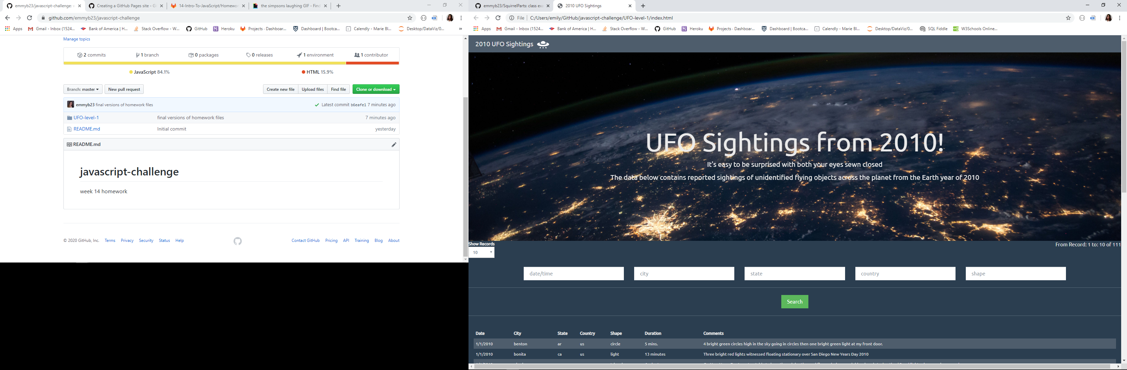

Loading page, shows 10 records by default but can see up to 100 total at a time including a count of records of total in upper right

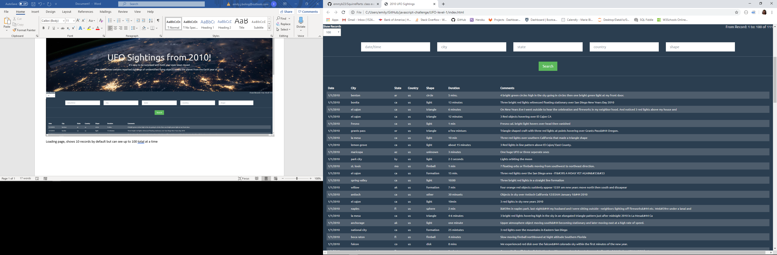

Records 1 to 100 of 111

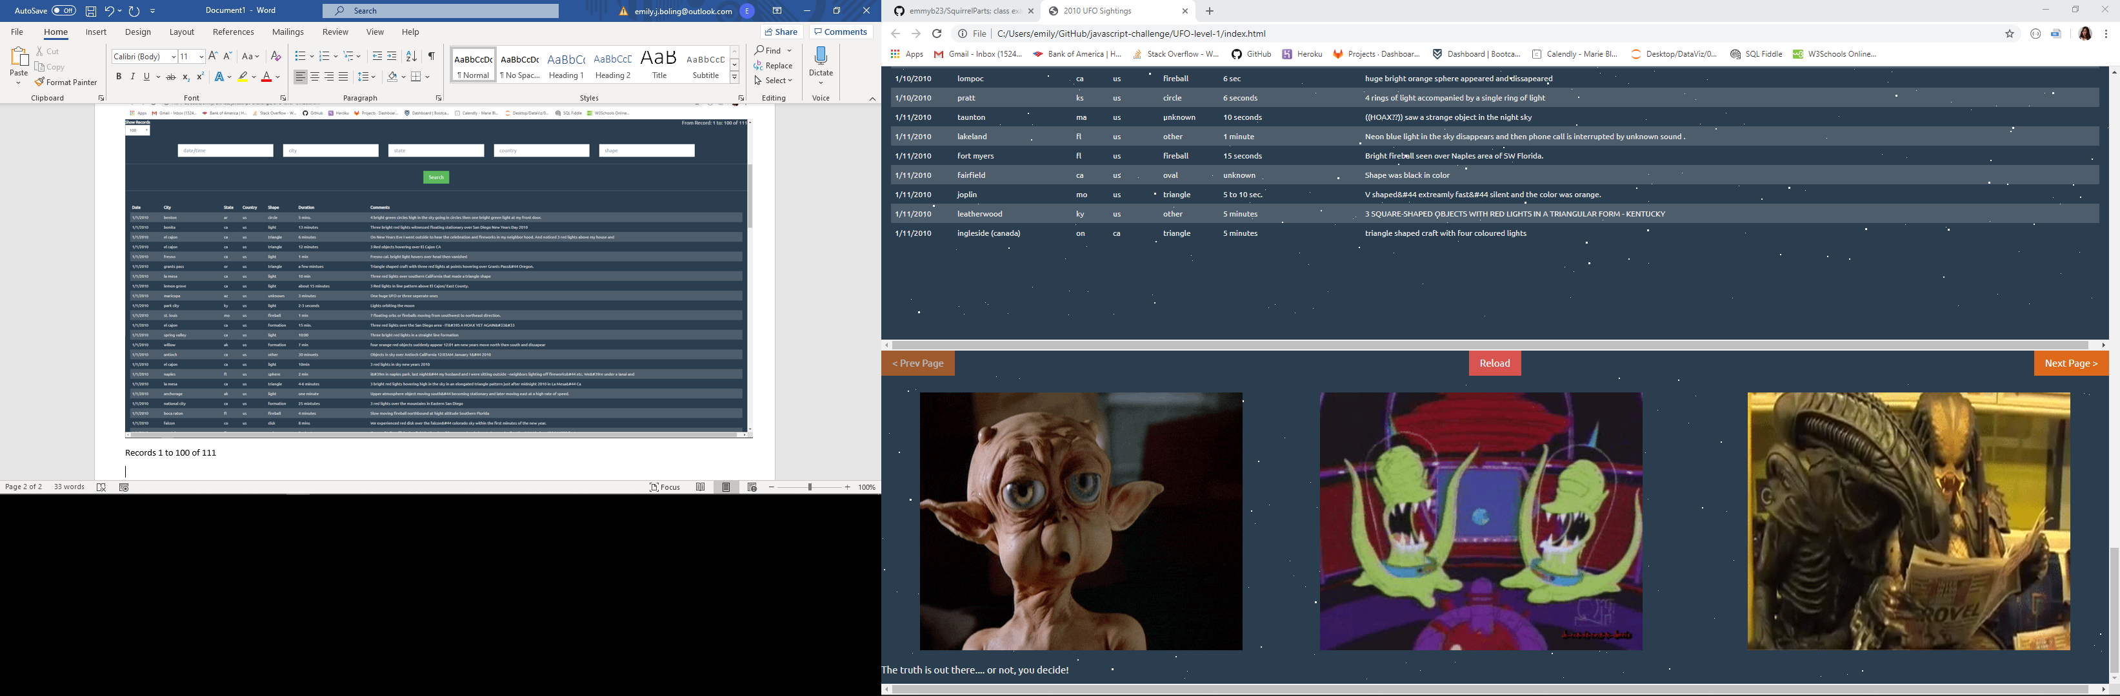

Bottom of page has option to reload data to default and advance to next page of data or previous page. I also included some fun alien gifs.

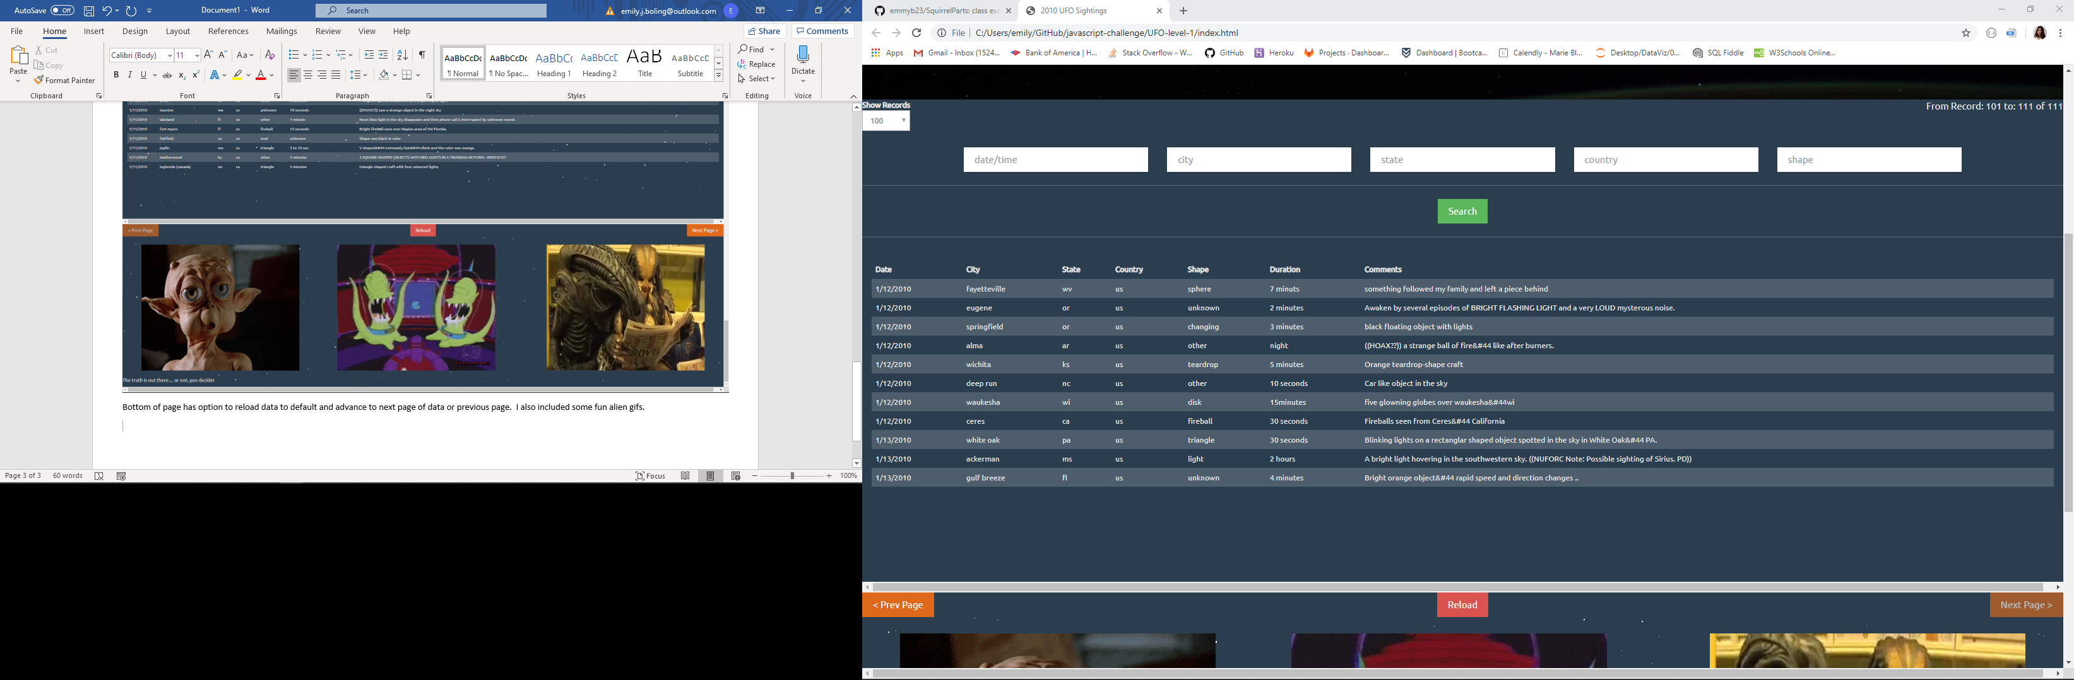

An example of how the next page works, this is showing the remaining records (101 to 111 of 111).

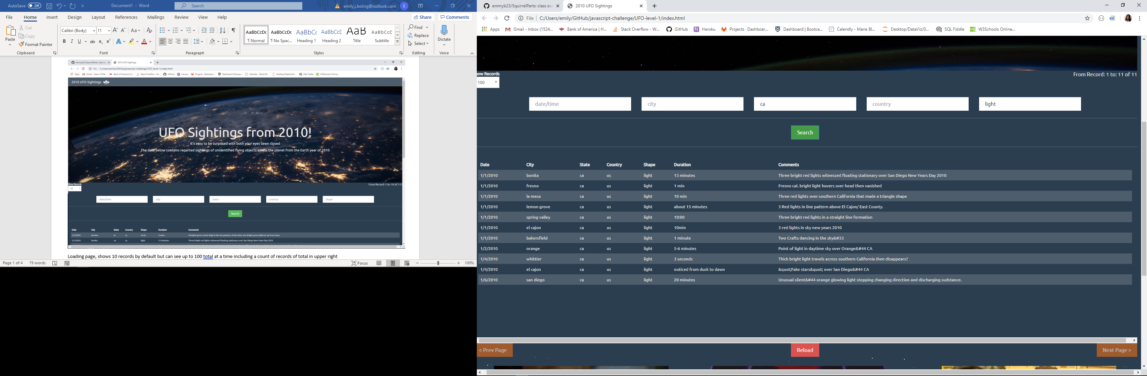

Users can search on multiple criteria, example above shows all the light shaped UFOs from California (11 records)